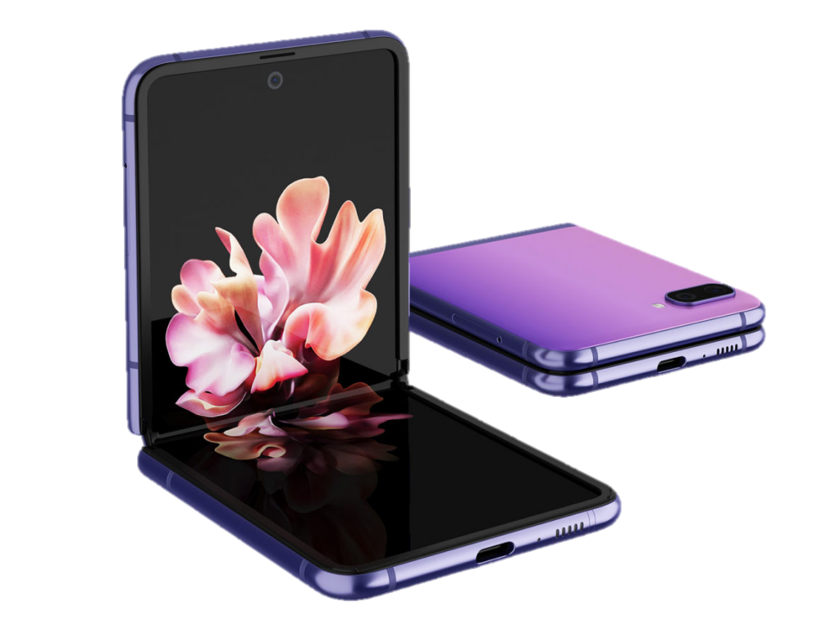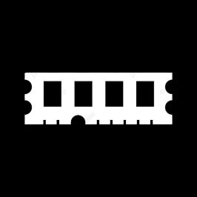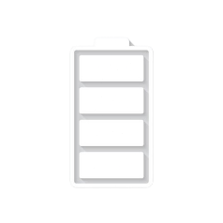

GALAXY Z FLIP Processor:

Qualcomm SM8150 Snapdragon 855+ (7 nm)

Front Camera: 10 MP

* Rear Camera:12 MP
* Display:6.7 “
* NFC: Yes
* Colors: Mirror Black, Mirror Purple, Mirror Gold, Thom Browne Edition
* Operating System:

Android 10

* Charging Type:USB Type-C
* SIM:Nano-SIM,Esim
* Fingerprint:Yes
* Release Date: 2020, February 11

RAM

8

GB

ROM

256

GB

BATTERY

3300

mAh



+001-28272300-2466-2469



webmaster@cellinfo.com



A-65, ACME Co. ,

Street No. 12,

New York

Ask Me Ltd.